**Classroom Activity:Write a program to develop a school management system having different type of people(Students and Teacher) need to be represent in the system**

**Code:**

|  |
| --- |
| // Base class for people  class Person {  constructor(name, age) {  this.name = name;  this.age = age;  }    getDetails() {  return `${this.name}, Age: ${this.age}`;  }  }    // Derived class for Students  class Student extends Person {  constructor(name, age, grade) {  super(name, age);  this.grade = grade;  }    getDetails() {  return `${super.getDetails()}, Grade: ${this.grade}`;  }    study() {  return `${this.name} is studying.`;  }  }    // Derived class for Teachers  class Teacher extends Person {  constructor(name, age, subject) {  super(name, age);  this.subject = subject;  }    getDetails() {  return `${super.getDetails()}, Subject: ${this.subject}`;  }    teach() {  return `${this.name} is teaching ${this.subject}.`;  }  }    // School management system  class School {  constructor() {  this.people = [];  }    addPerson(person) {  this.people.push(person);  }    listPeople() {  return this.people.map(person => person.getDetails()).join('\n');  }    findPerson(name) {  return this.people.find(person => person.name === name);  }  }    // Create a new school  const school = new School();    // Add people to the school  const student1 = new Student('Alice', 14, '9th Grade');  const student2 = new Student('Bob', 16, '11th Grade');  const teacher1 = new Teacher('Mr. Smith', 40, 'Mathematics');    school.addPerson(student1);  school.addPerson(student2);  school.addPerson(teacher1);    // List all people in the school  console.log('People in the school:');  console.log(school.listPeople());    // Find a person by name  const nameToFind = 'Alice';  const foundPerson = school.findPerson(nameToFind);  console.log(`\nFound person with name ${nameToFind}:`);  console.log(foundPerson ? foundPerson.getDetails() : 'Person not found');    // Demonstrate specific behaviors  console.log(`\nSpecific behaviors:`);  console.log(student1.study());  console.log(teacher1.teach()); |

**Output:**

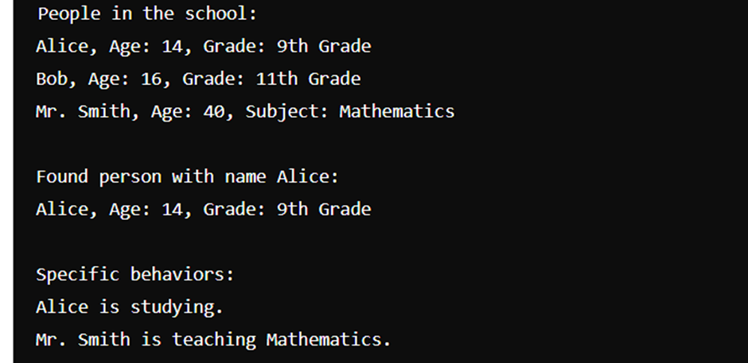

**Execution-Steps:**

* Create a JavaScript file with any name
* Write the code
* Run the code in the terminal using F5 or right click and go to inspect and you can get the output in the console as well.